Module 8: SQS and SES Assignment
Problem Statement:
You work for XYZ Corporation. Your team is asked to deploy similar architecture multiple times for testing, development, and production purposes. Implement CloudFormation for the tasks assigned to you below.
Tasks To Be Performed:
1. Create a FIFO SQS queue and test by sending messages.
2. Register your mail in SES and send a test mail to yourself.

1. Create a FIFO SQS queue and test by sending messages.
Create the Dead Letter Queue (DLQ) : My-DLQ.fifo
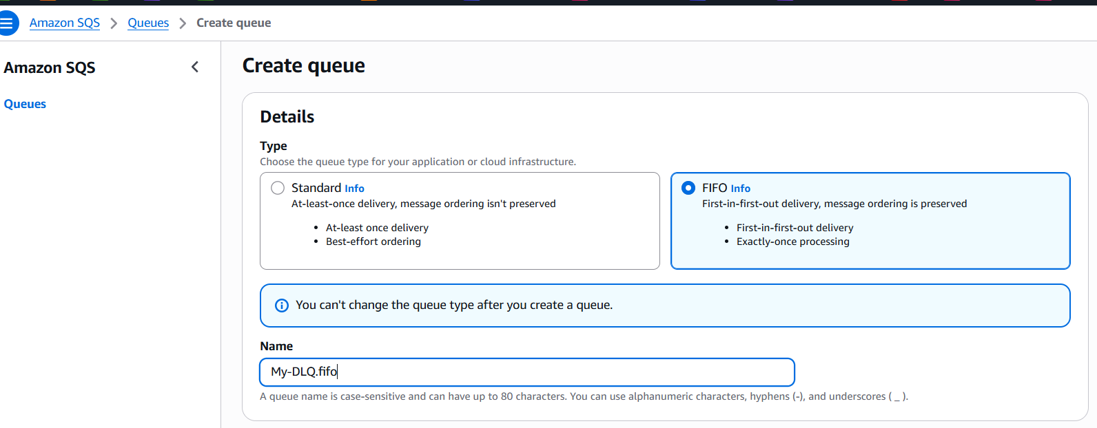
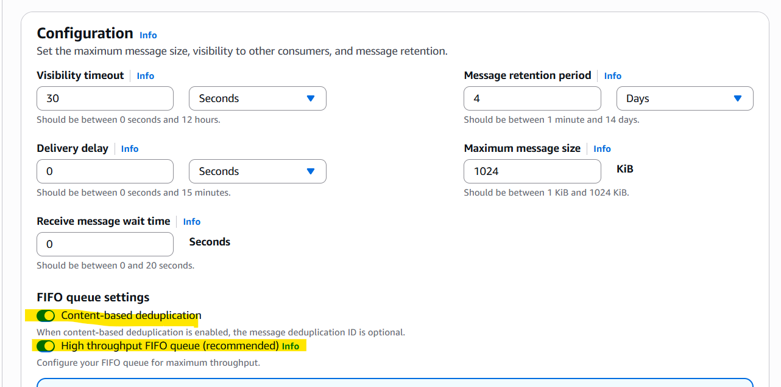
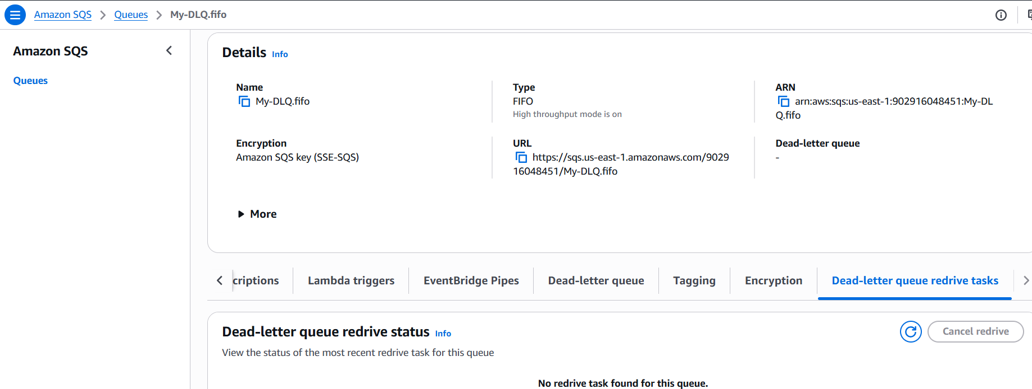

Create the Main FIFO Queue: My-MainQueue.fifo
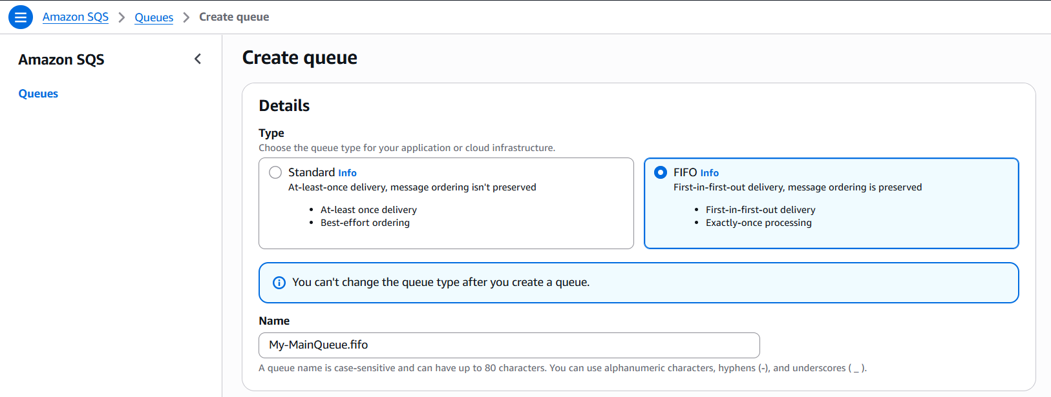
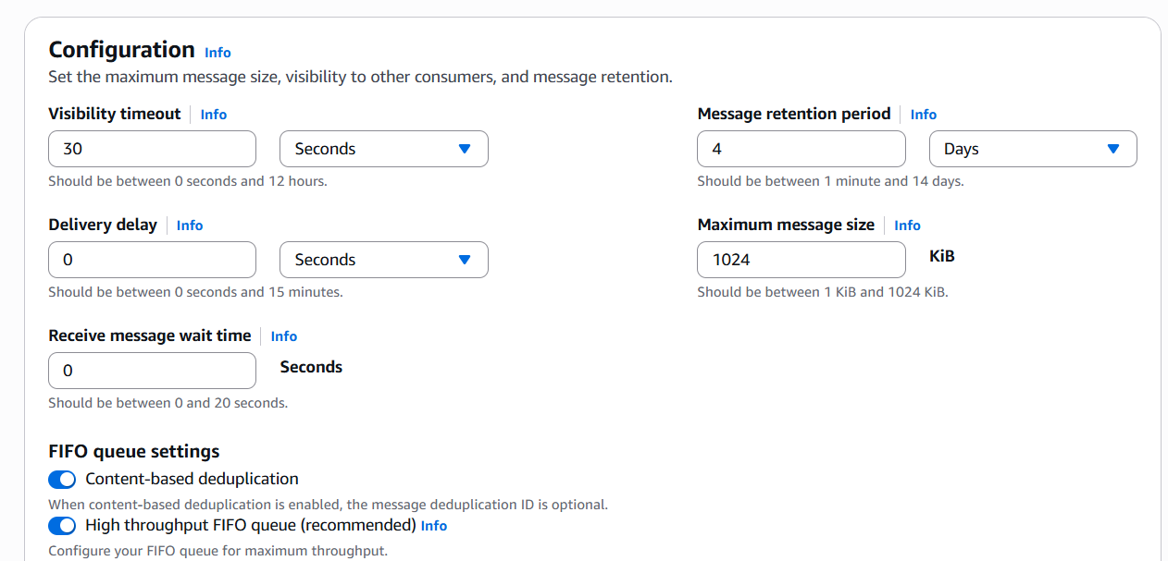
Configure Dead Letter Queue:
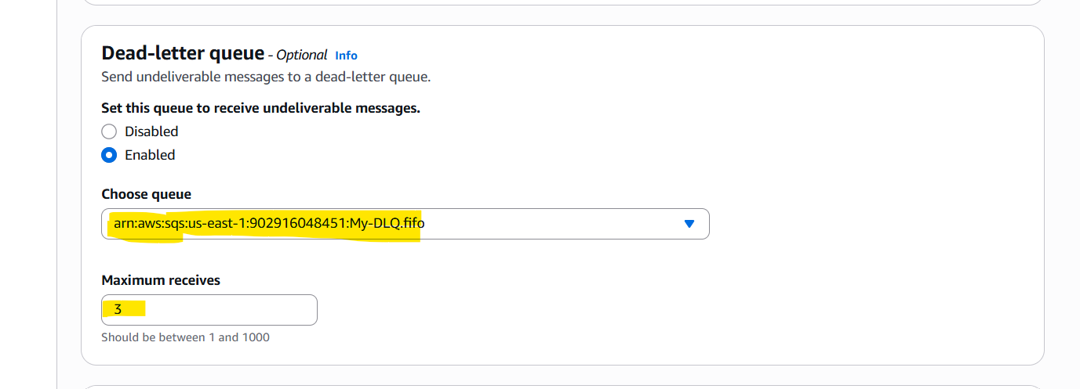
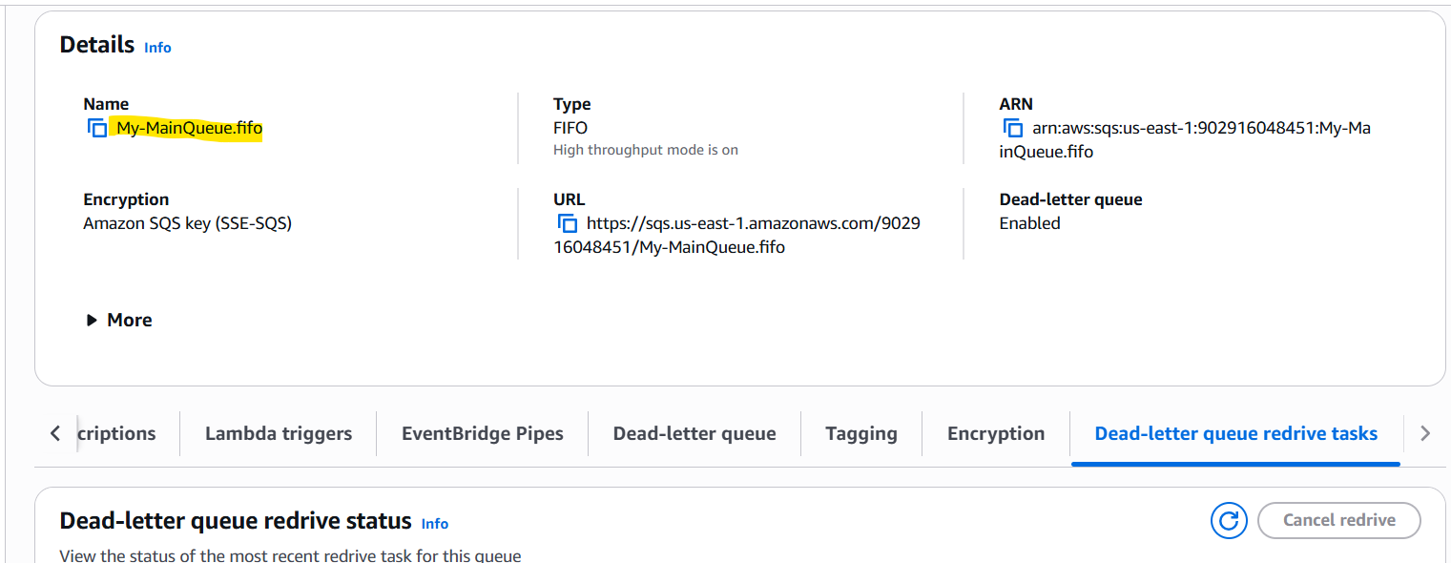
Send Messages: Order-101 (group-01)
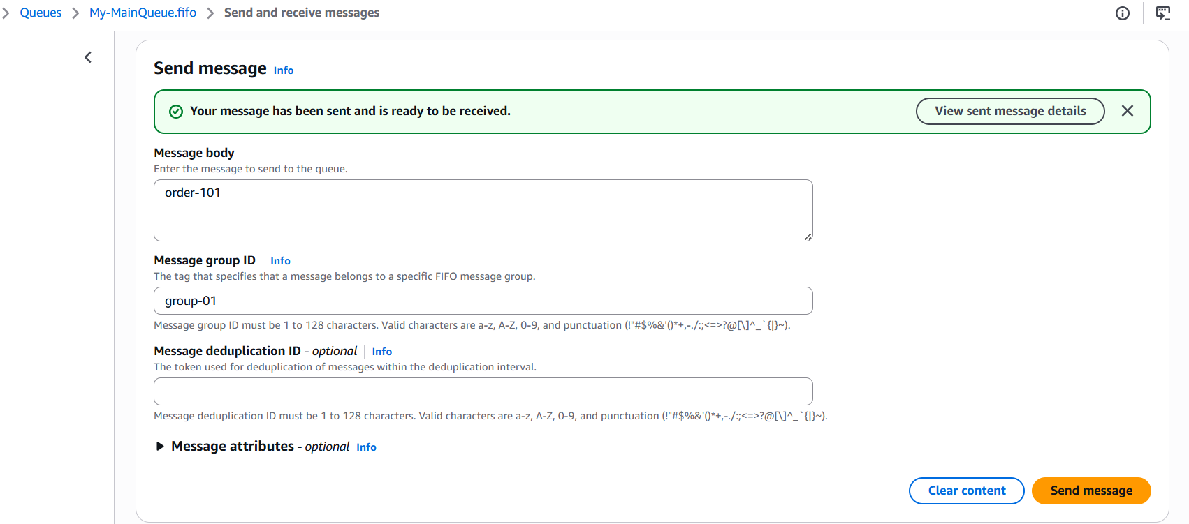
Send Messages: Order-102 (group-01)
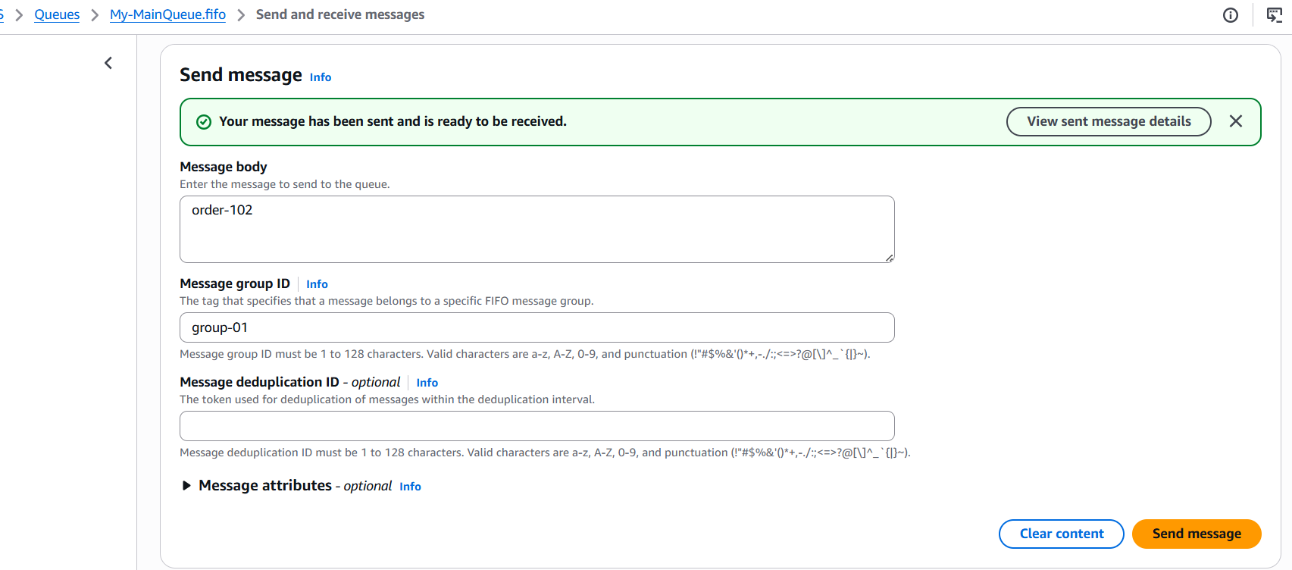
Send Messages: Order-103 (group-01)
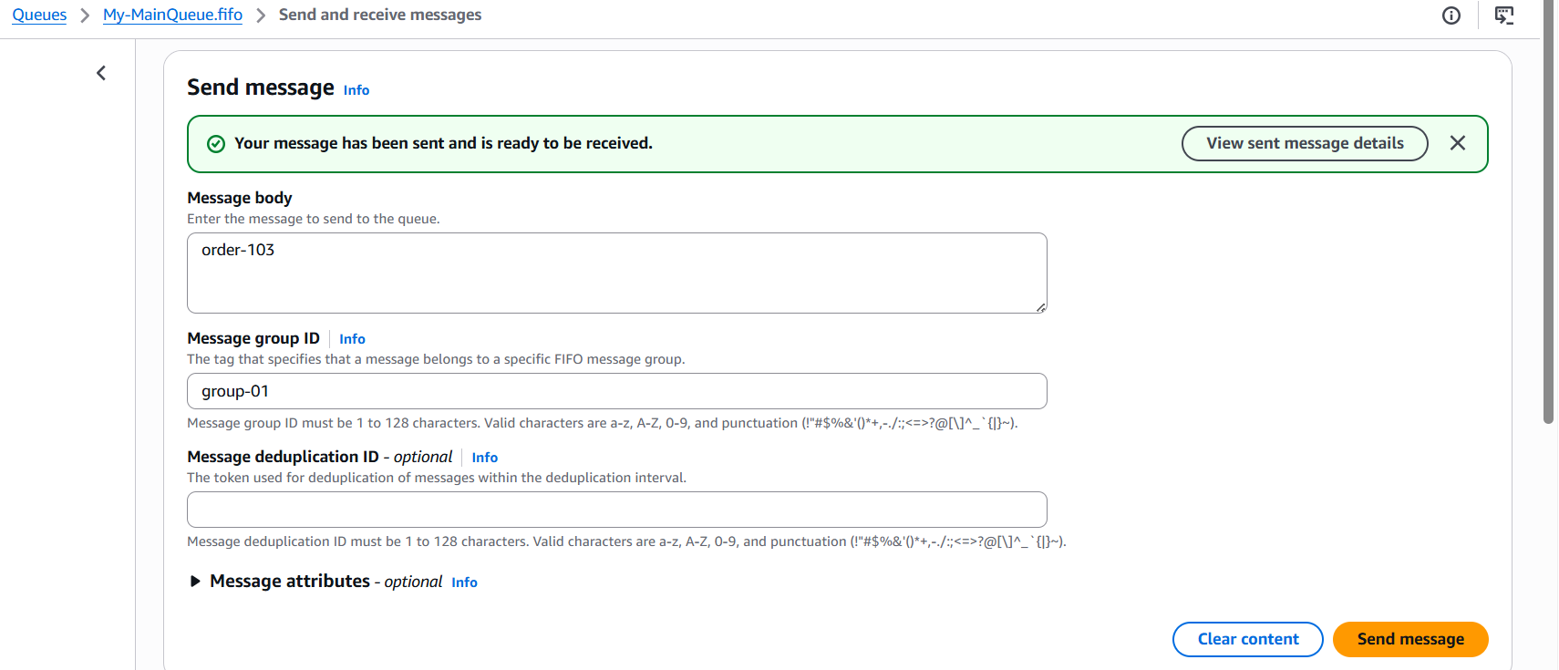
Receive the First Message:
- order-101 in the main queue (4b9a2ee8-cb4c-4f4f-9f6c-ae8ae10aac9c)
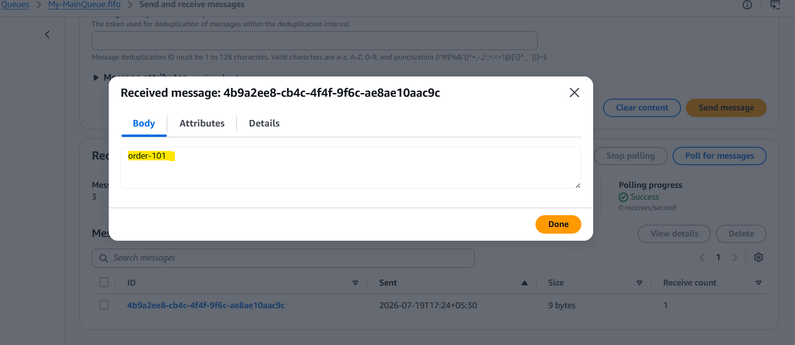
- order-102 in the main queue
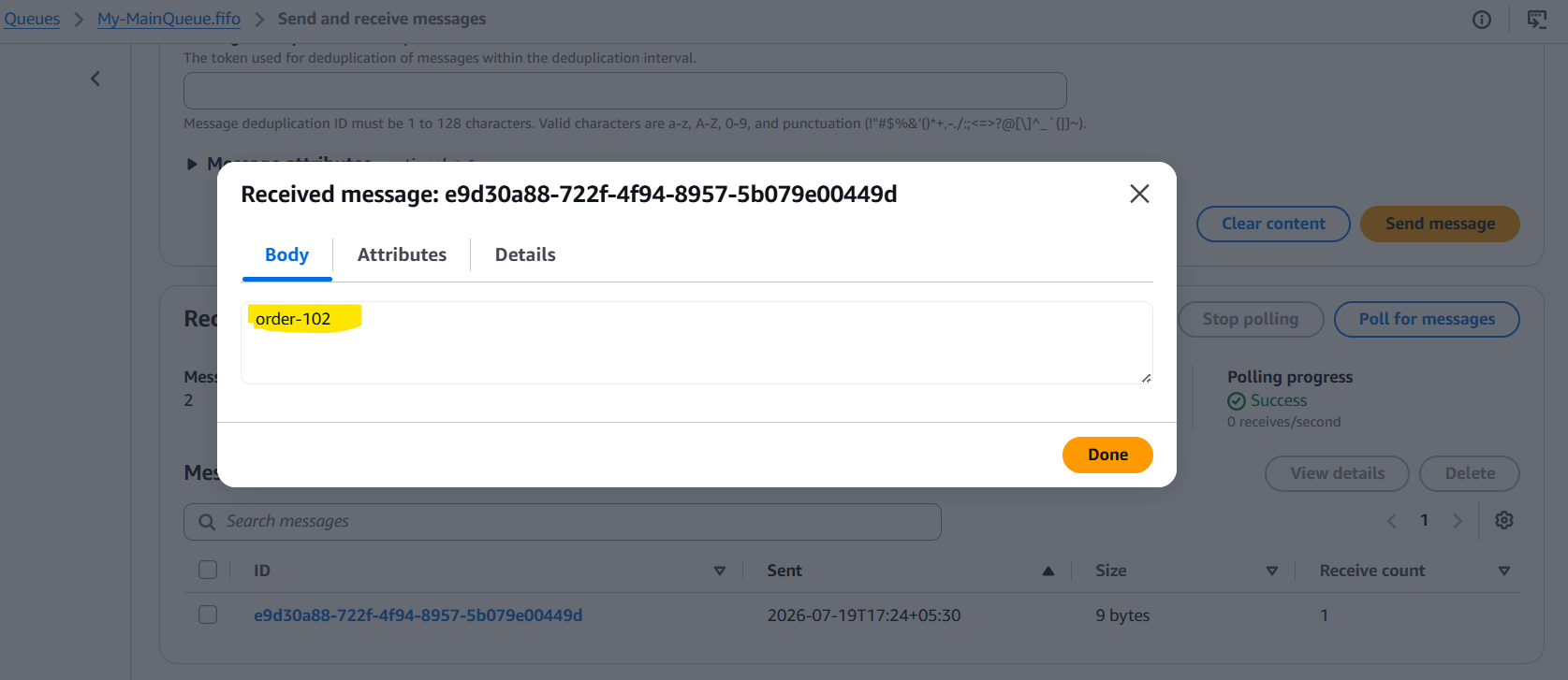
- Order-101 in the Dead Letter queue (4b9a2ee8-cb4c-4f4f-9f6c-ae8ae10aac9c)
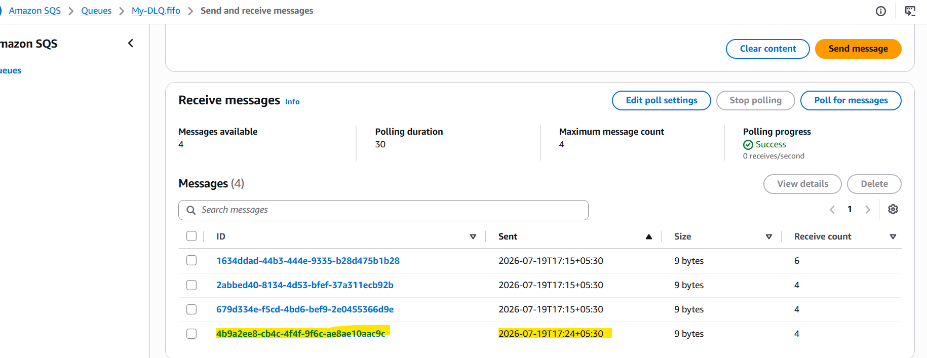
- Order-103 in the main queue
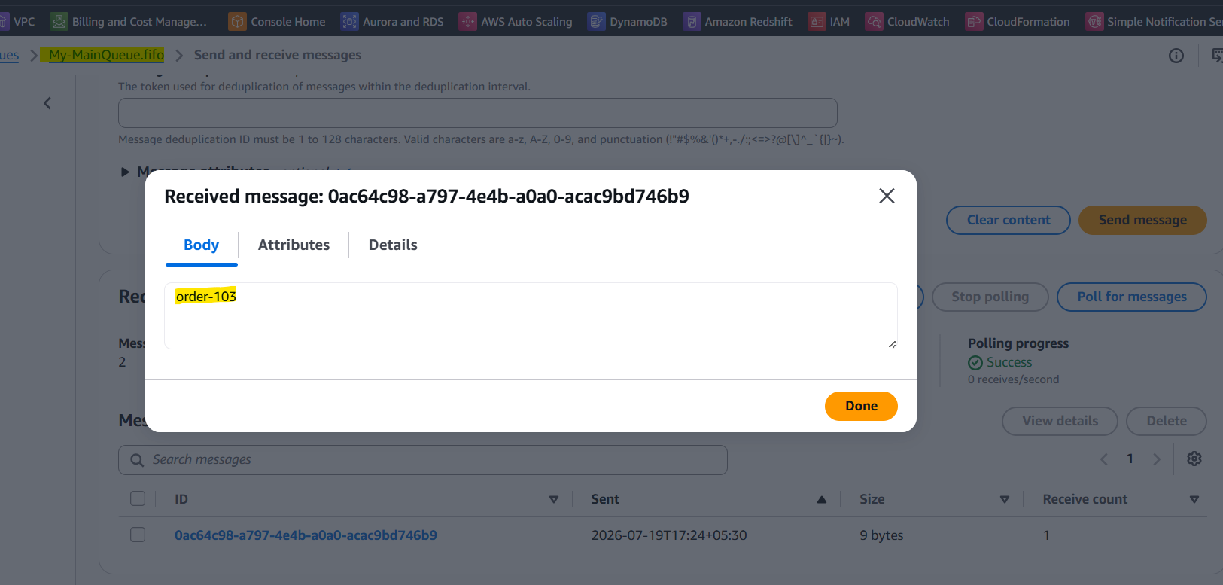
- Order-102 in the Dead Letter queue:
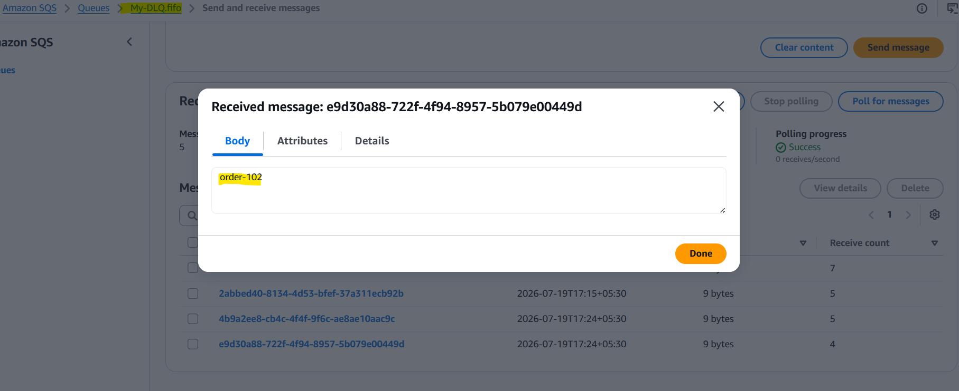

2. Register your mail in SES and send a test mail to yourself.
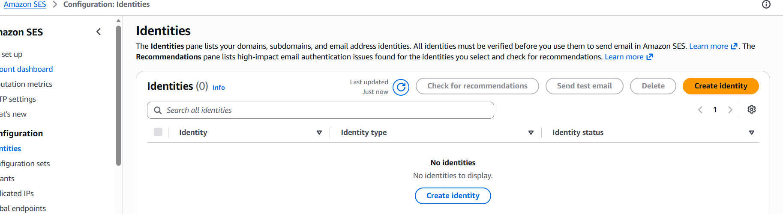
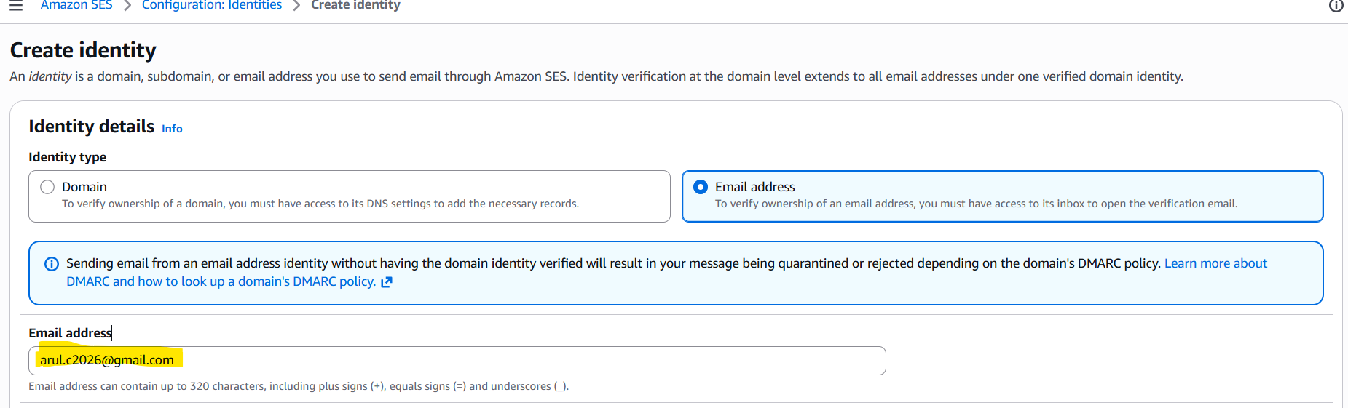

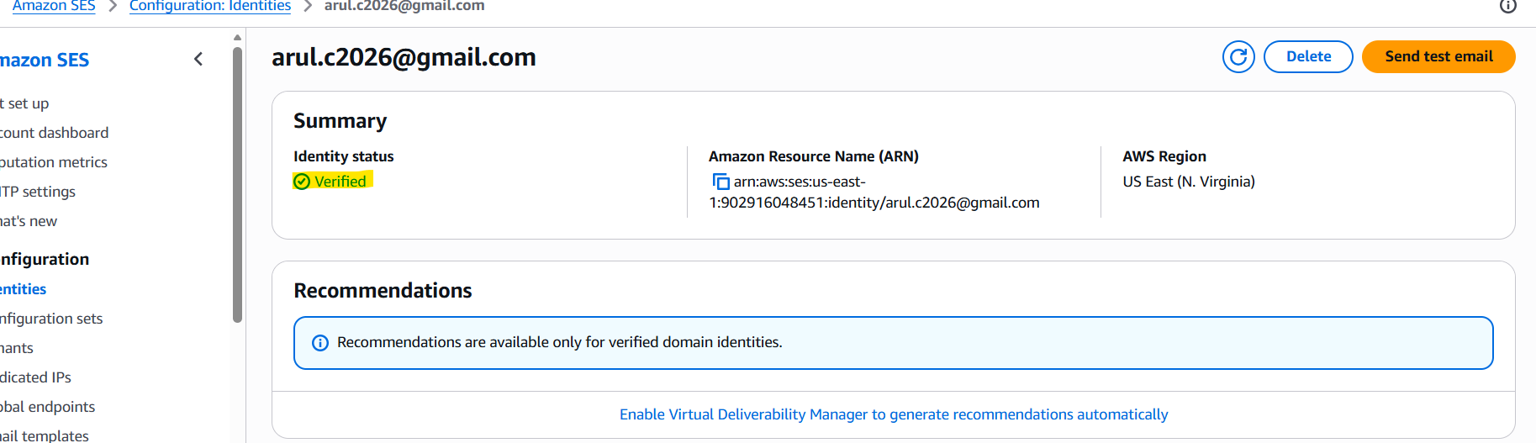

Created another Identity - salemarul1991@gmail.com:
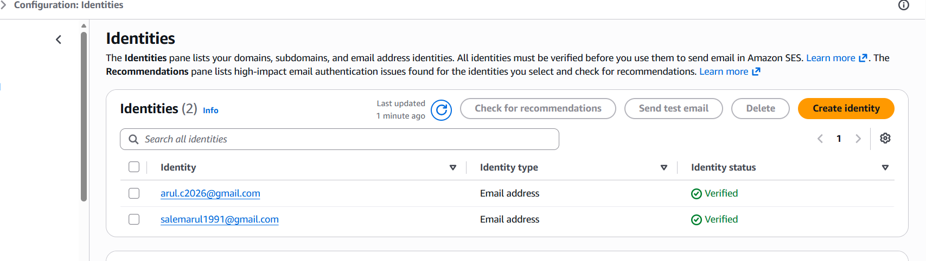
Sending mail from one entity to another:
